**Practical No : 1**

**Experiment No : 1**

**Aim** : Write a program to show the arithmetic operations of complex number.

**1) Addition :**

Source Code :

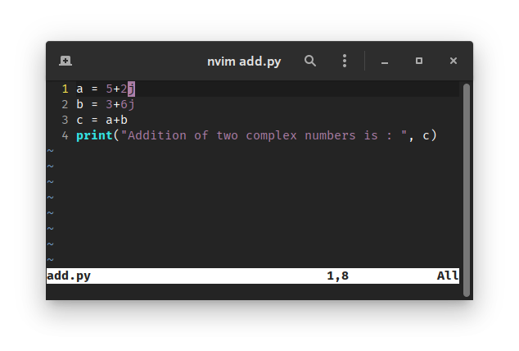

Output :

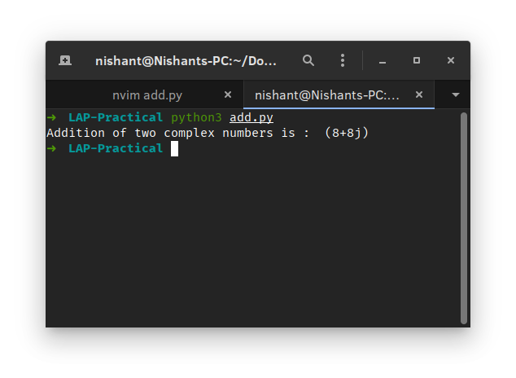

**2) Substraction :**

Source Code :

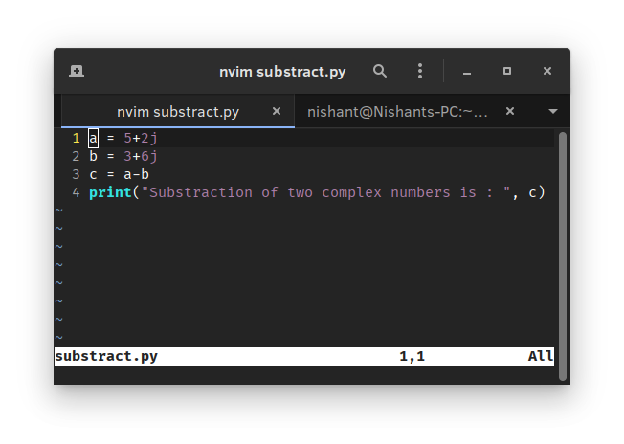

Output :

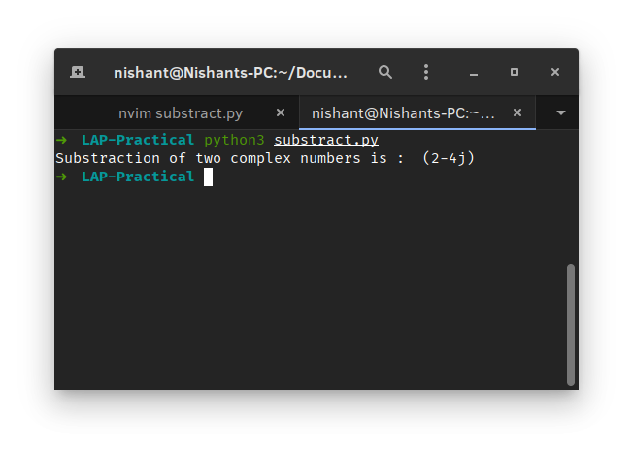

**3) Multiplication:**

Souce Code:

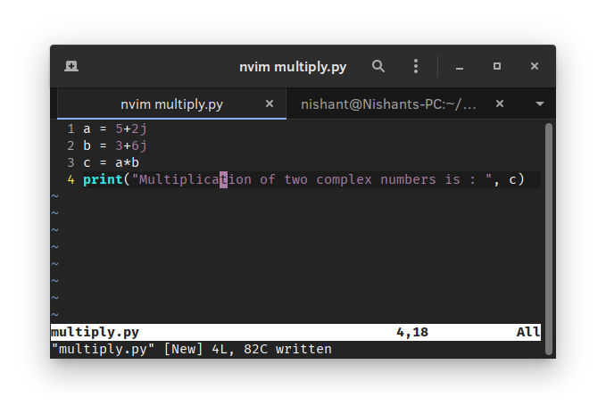

Output:

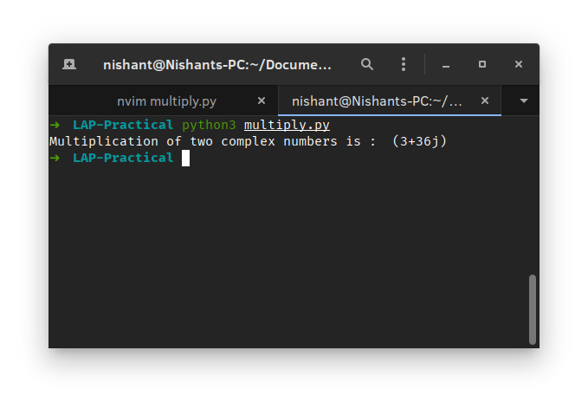

**4) Division:**

Souce Code:

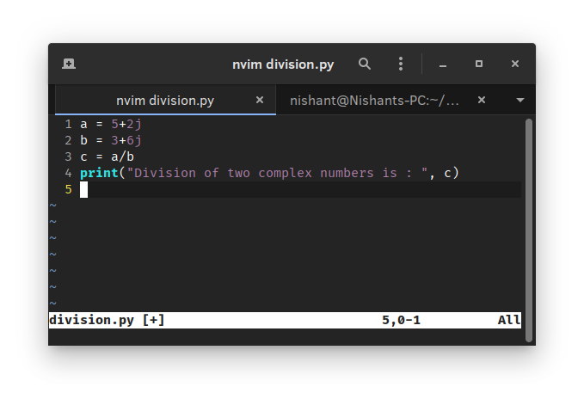

Output:

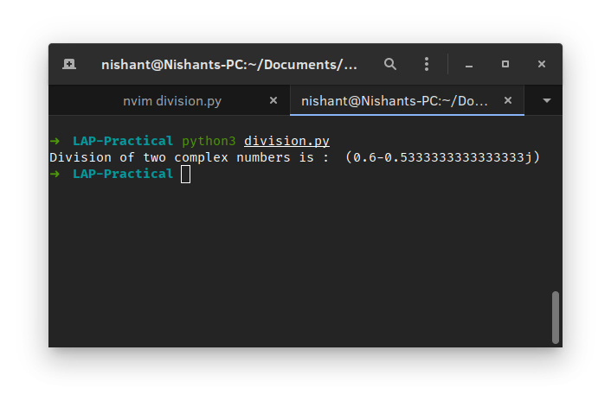

**Experiment No : 2**

**Aim** : to display the conjugate of a Complex Number.

Source Code :

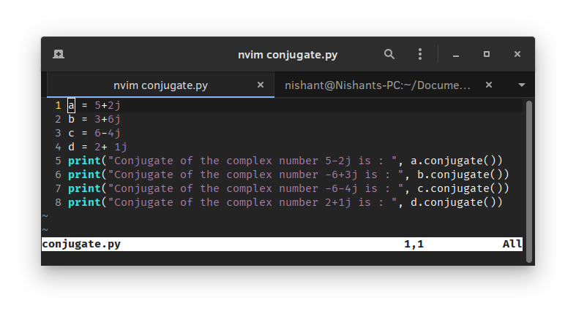

Output:

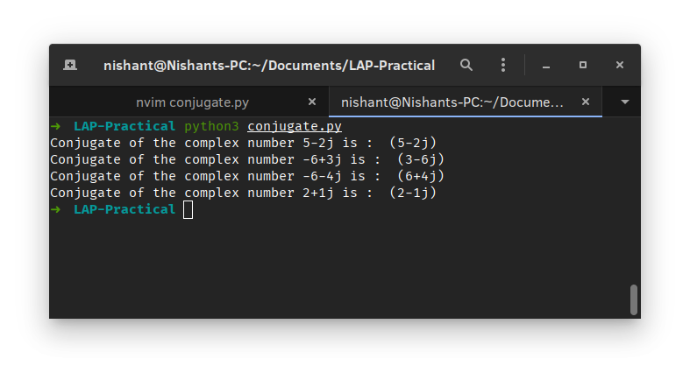

**Experiment No : 3**

**Aim**: Displaying absolute values of a Complex Number.

Source Code:

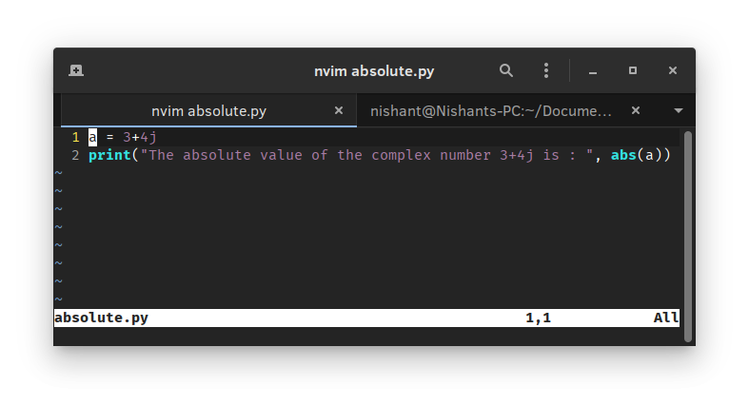

Output:

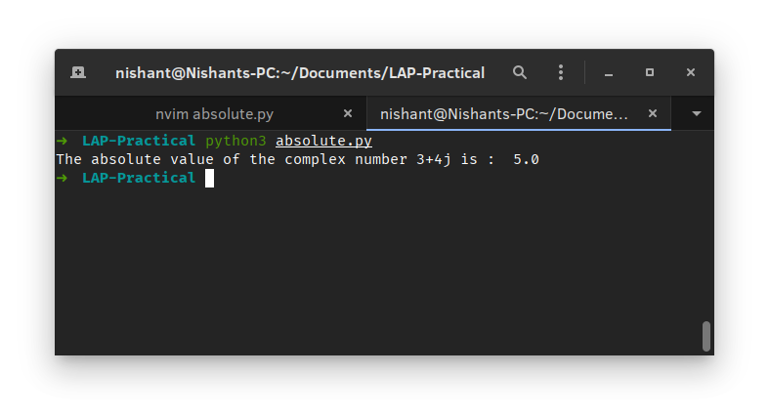

**Experiment No : 4**

**Aim**: Plotting a set of Complex Numbers.

Source Code:

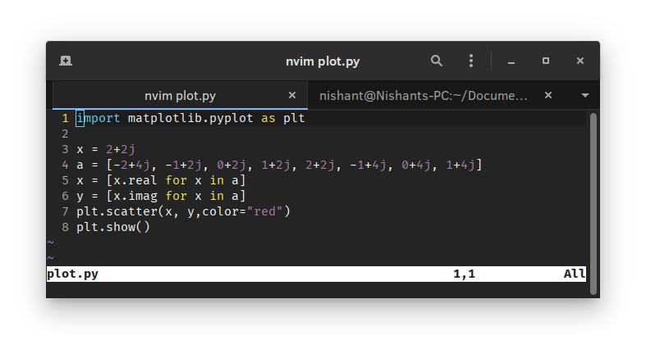

Output:

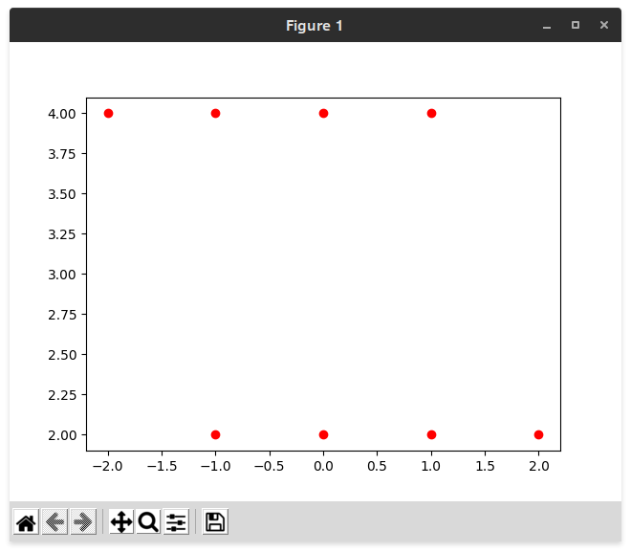

**Experiment No : 5**

**Aim**: Creating a new plot by rotating the given number by a degree 90,180,270 degrees and also by scaling by a number a = 1/2, a = 1/3, a = 2 etc.

**Rotation by 90:**

Source Code:

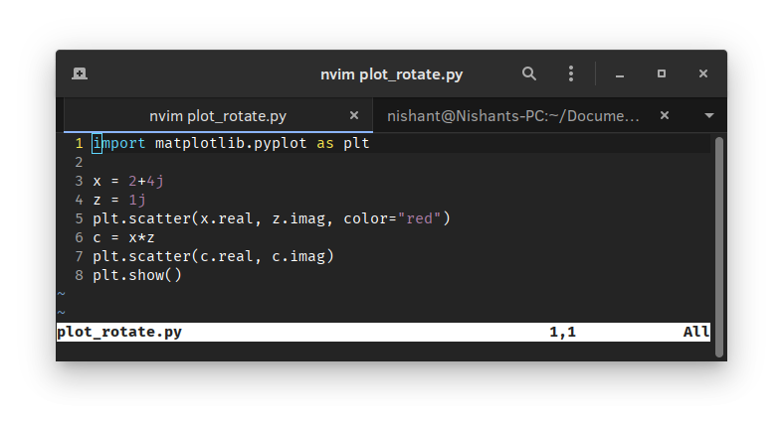

Output:

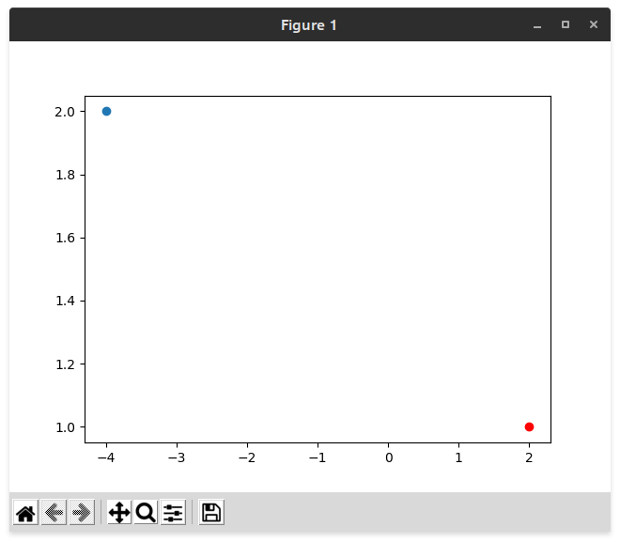

**Rotation by 180:**

Source Code:

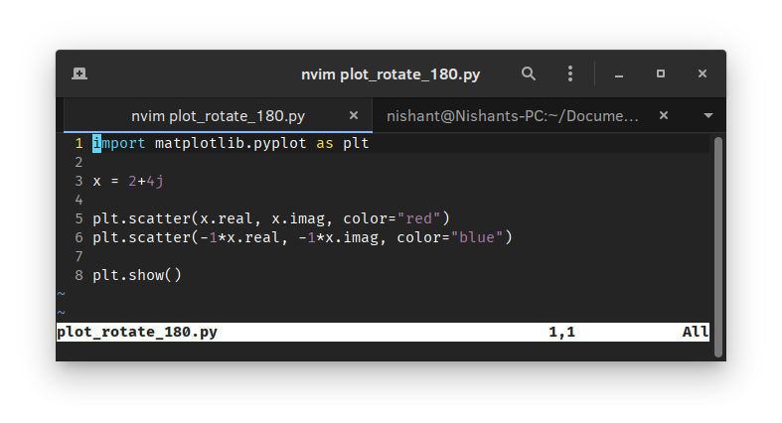

Output:

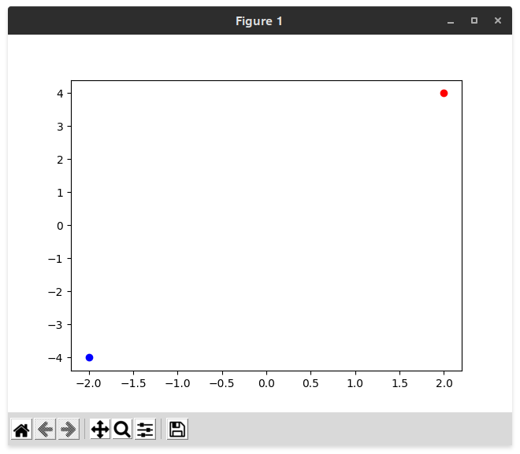

**Rotation by 270:**

Source Code:

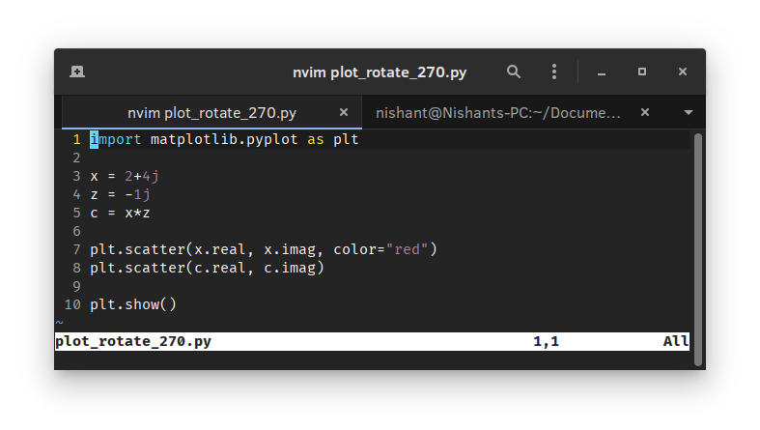

Output:

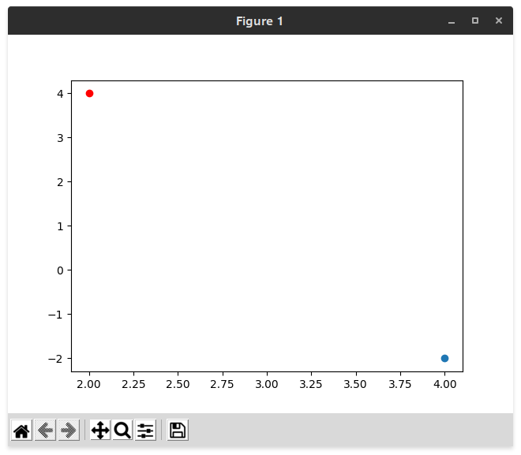

**Scaling by a=1/2, a=1/3 and a=2:**

Source Code:

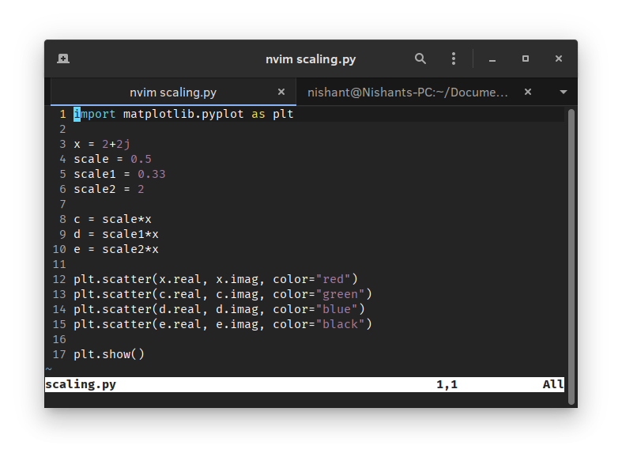

Output:

